Lab: Provision a Windows Virtual Machine on Azure
In this lab you’ll create a Windows virtual machine (VM) in Microsoft Azure using the Azure Portal. You’ll set up the VM, open RDP (Remote Desktop) access, sign in to Windows, and (optional) install IIS to verify networking with a simple web page.

Learning Objective
By the end of this lab, you will be able to:
- Create an Azure resource group and a Windows VM in a chosen region.
- Choose a VM image (Windows Server), size, disk, and network options.
- Enable and use RDP to connect to the VM from your computer.
- (Optional) Install IIS and serve a simple page to confirm connectivity.
- Stop or delete resources to avoid unnecessary costs.

Pre-Requisite
- Azure account & subscription.
- A modern browser (Edge/Chrome/Firefox).
- Ability to use Remote Desktop:
  - Windows 10/11: built-in “Remote Desktop Connection”.
  - macOS: install “Microsoft Remote Desktop” from the App Store.
- Stable internet connection.
- A simple naming plan (e.g., resource group: rg-win-lab, VM name: vm-win-lab).

Steps to Follow

Part A — Create a Resource Group (1–2 min)
- Go to https://portal.azure.com and sign in.
- In the top search bar, type Resource groups → Create.
- Fill in:
  - Subscription: your subscription
  - Resource group: rg-win-lab
  - Region: pick one near you (e.g., East US, West Europe, Central India)
- Click Review + create → Create.
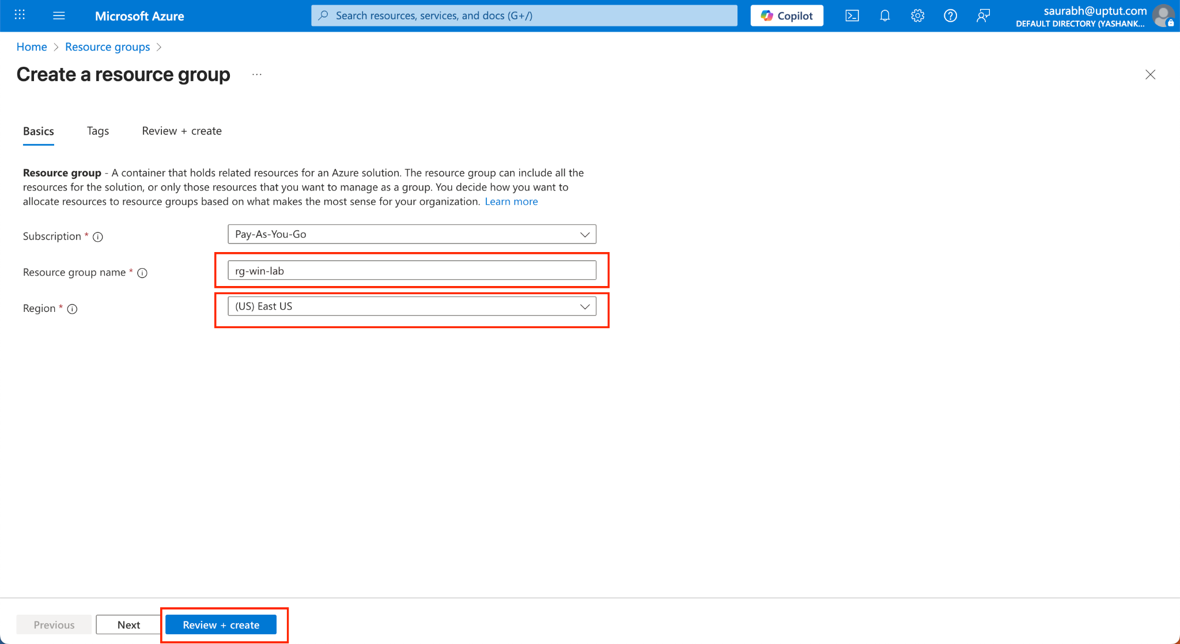

Part B — Create a Windows VM
- In the search bar, type Virtual machines → Create → Azure virtual machine.
- Basics tab:
  - Subscription: your subscription
  - Resource group: rg-win-lab
  - Virtual machine name: vm-win-lab
  - Region: same as the resource group
  - Availability options: No infrastructure redundancy required
  - Security type: Standard
  - Image: Windows Server 2022 Datacenter: Azure Edition – Gen2 (recommended)
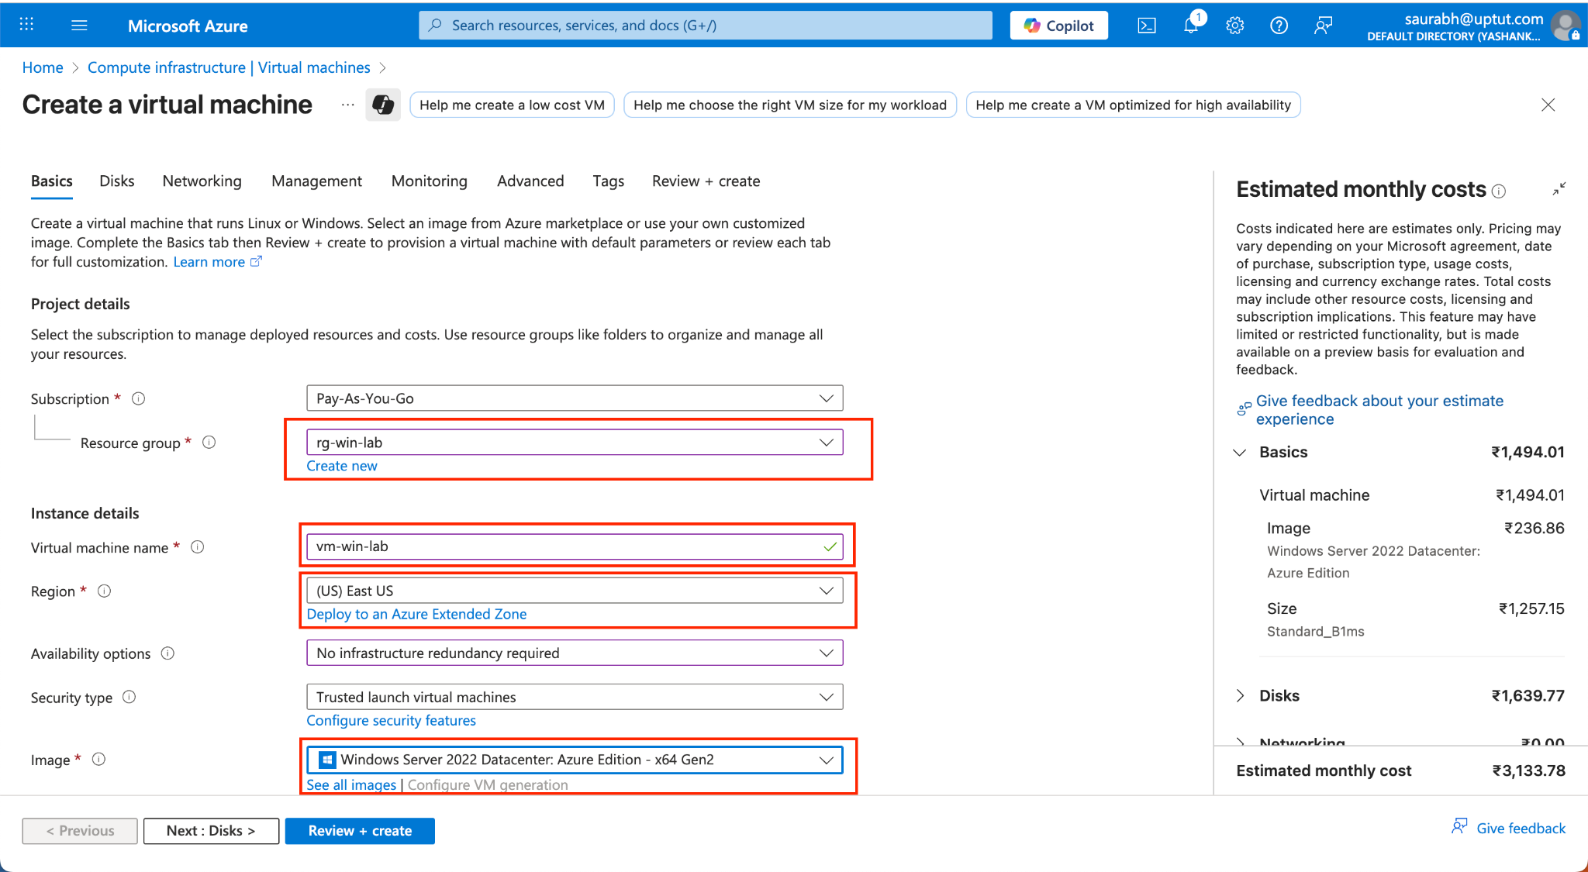

  - Size: click Change size → pick a small size (e.g., Standard_B1ms)
  - Administrator account:
    - Username: e.g., azureuser
    - Password: create a strong password (save it!)
  - Inbound port rules:
    - Public inbound ports: Allow selected ports
    - Select inbound ports: RDP (3389)
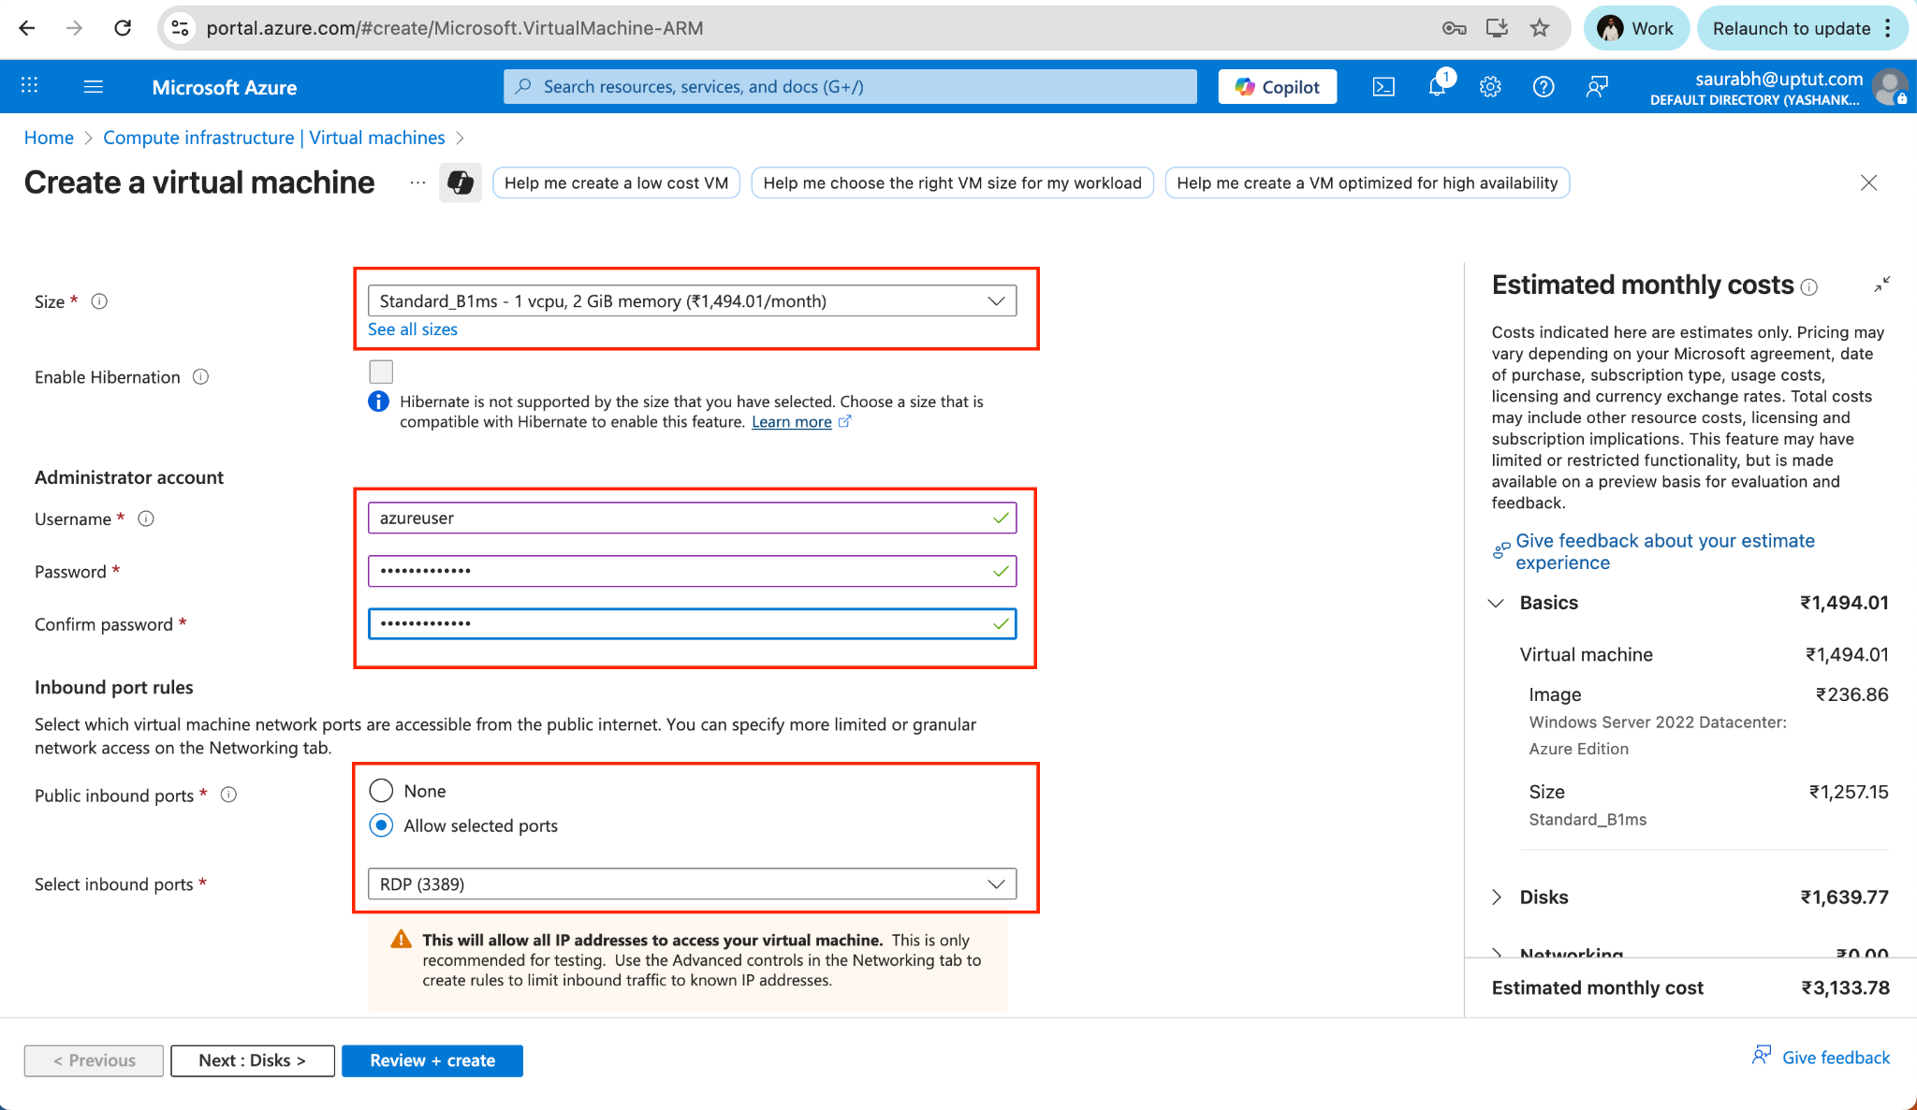
- Disks tab:
  - OS disk type: Standard SSD (cost-effective for labs)
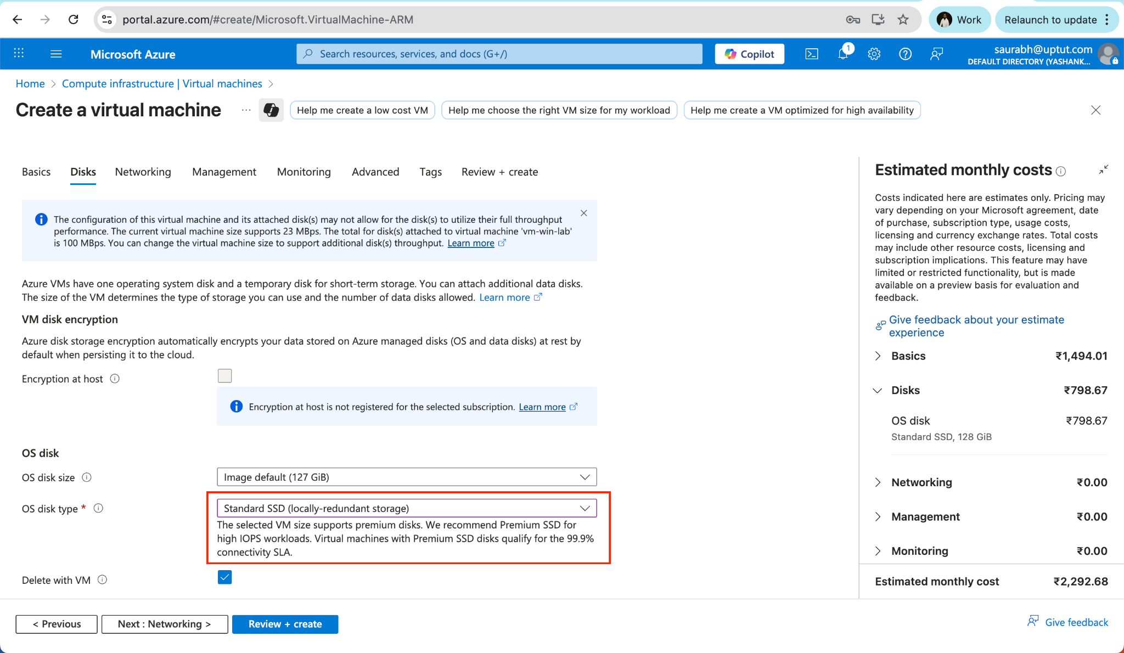
- Networking tab:
  - Virtual network: accept default or auto-created
  - Subnet: default
  - Public IP: Create new (default name is fine)
  - NIC network security group: Basic
  - Public inbound ports: Allow selected ports: RDP (3389)
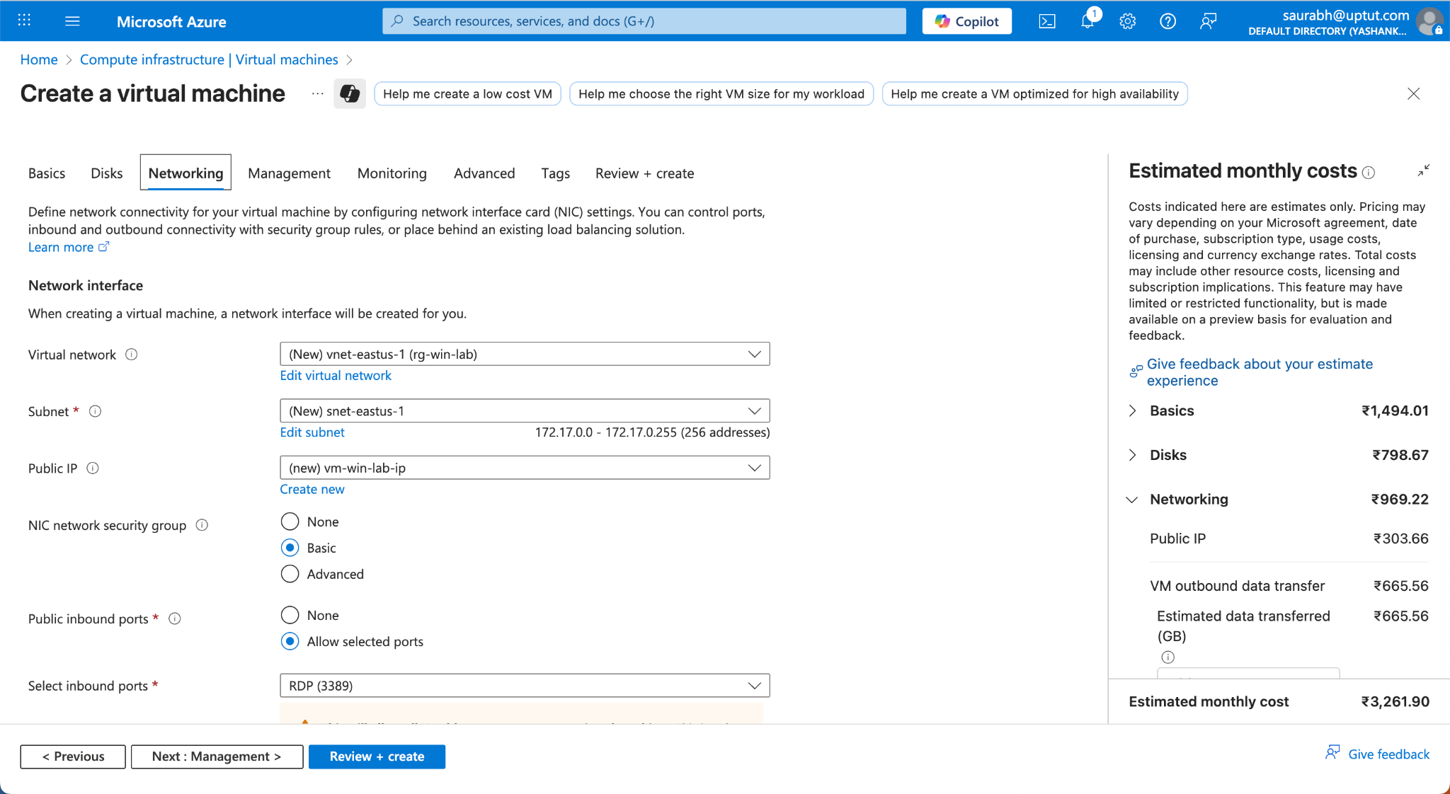
- Management tab (optional but helpful):
  - Auto-shutdown: On (choose a time) to save costs if you forget
  - Leave other defaults
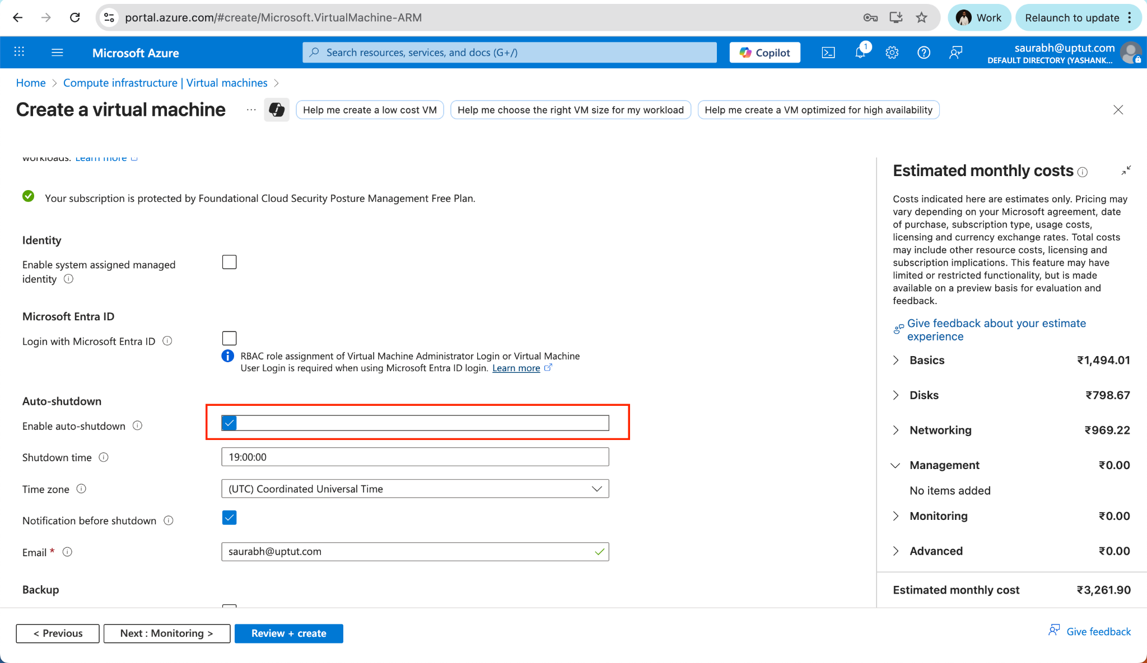
- Monitoring / Advanced / Tags: leave defaults
- Click Review + create → wait for validation → Create.
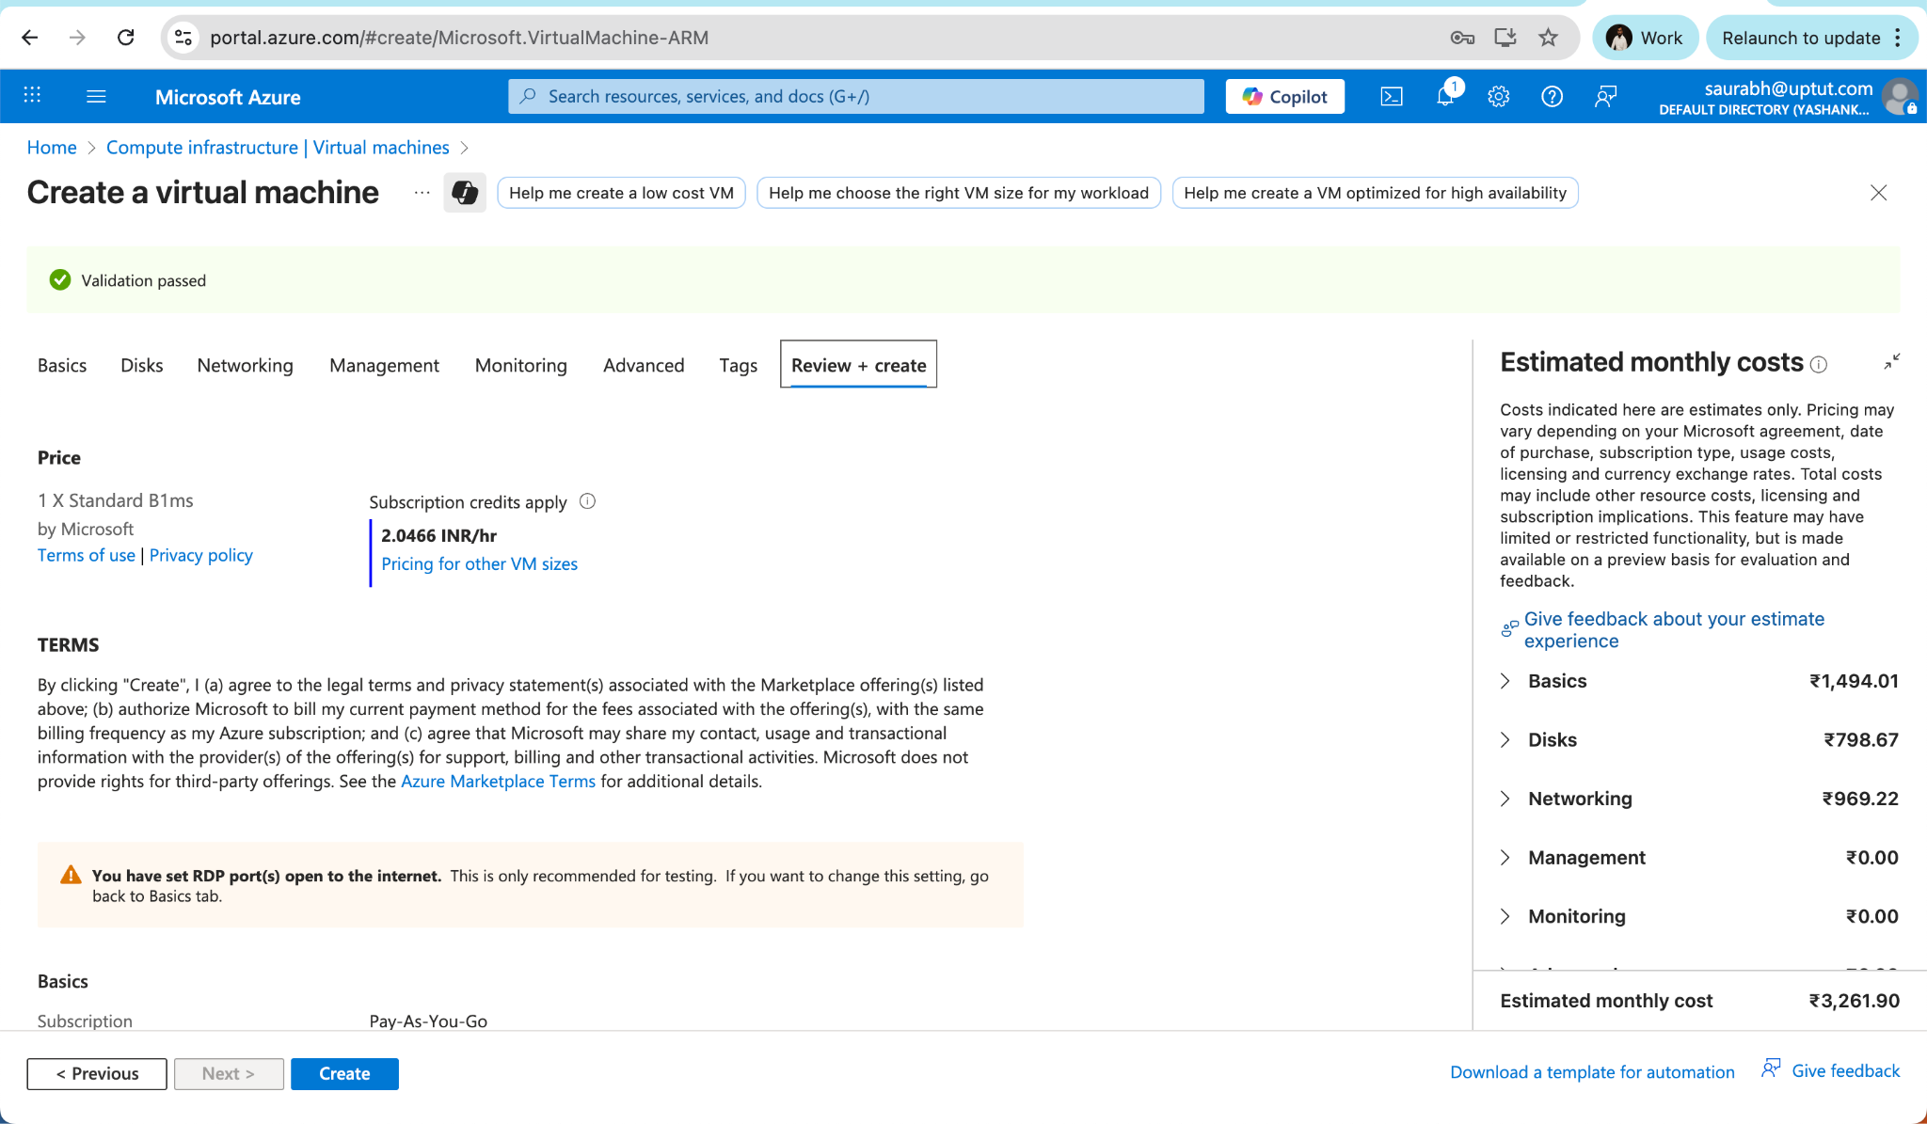
Deployment takes a few minutes. When it’s done, click Go to resource.

Part C — Note the Public IP
- On the VM Overview page, copy the Public IP address (e.g., 20.x.x.x).
You’ll use this to connect via Remote Desktop.
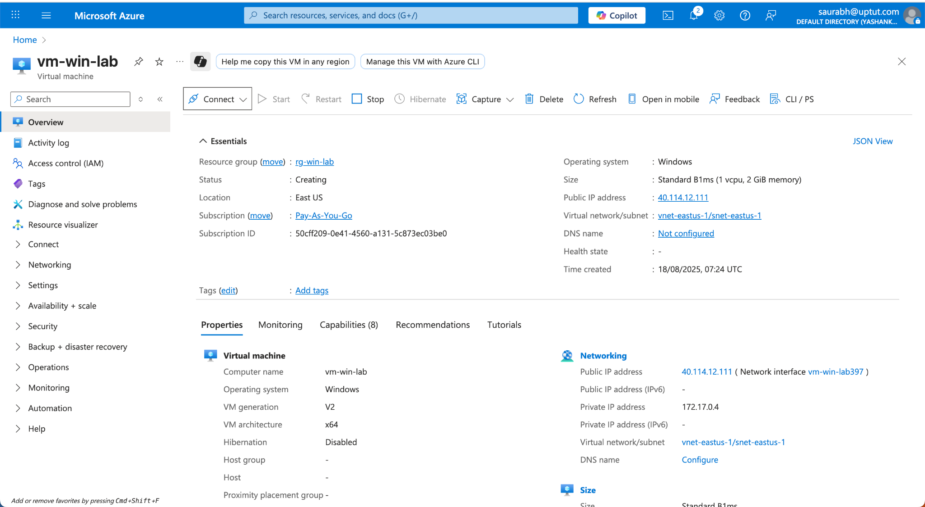

Part D — Connect via Remote Desktop (RDP) (Windows)
Option 1: Connect from the Azure Portal
- On the VM page, click Connect → RDP.
- Click Download RDP file, then open it.
- When prompted, click Connect.
- Enter your Username and Password from the Basics tab.
- Accept any certificate warning → you should land on a Windows desktop.
Option 2: Connect using your OS’s Remote Desktop app
- Open Remote Desktop Connection (Windows) or Microsoft Remote Desktop (macOS).
- Computer / PC name: the VM’s Public IP
- Click Connect → enter Username and Password → OK / Continue.
If you see the Windows desktop, your VM is running and reachable.

Part E — (Optional) First-Run Setup
Inside the Windows VM:
- Let Windows finish any initial setup/updates.
- Open Settings → Windows Update to check for updates (optional in a quick lab).
- Optionally rename the computer (Server Manager → Local Server) and reboot.

Part F — (Optional) Install IIS to Verify Networking
We’ll install a basic web server (IIS) and serve a simple page. This confirms inbound connectivity (HTTP).
Method 1: Server Manager GUI
- Open Server Manager → Add roles and features.
- Click Next through Before you begin, Installation Type (Role-based), and Server Selection.
- Server Roles: check Web Server (IIS).
- Accept required features → Next → Install → wait for completion.
Allow HTTP (port 80) in the NSG:
- In Azure Portal → go to your VM → Networking.
- Click Add inbound port rule.
  - Destination port ranges: 80
  - Protocol: TCP
  - Action: Allow
  - Priority: e.g., 1000
  - Name: allow-http
- Add the rule.
Test from your local computer:
- Open a browser to http://<Public_IP>/
You should see your Hello from IIS page.

Part G — Stop or Clean Up (to avoid charges)
- Stop (deallocate) the VM to pause compute billing:
  - VM page → Stop (you can Start it later).
- Delete everything when finished:
  - Go to Resource groups → open rg-win-lab.
  - Click Delete resource group → type the name to confirm → Delete.

Troubleshooting Tips
- RDP won’t connect / timeout
  - VM Status should be Running.
  - Networking → Inbound port rules must allow RDP (3389).
  - Your local network must allow outbound RDP (port 3389).
  - Try from another network if your firewall blocks RDP.
- Wrong credentials
  - Use the exact username and password set on the Basics tab.
- HTTP (IIS) not reachable
  - Confirm IIS is installed and the index.html exists.
  - Ensure the NSG rule for port 80 is Allow.
  - Test inside the VM: open Internet Explorer/Edge → http://localhost/.

